Best Fintech Software Development Companies for Enterprises in the USA in 2023

Over the past few years, the Fintech industry has seen remarkable growth and disruption, with major global brands such as Walmart, Ikea, and Amazon tapping into the world of financial software services, specifically designed for their customers. They have radically cut out traditional intermediaries to provide their consumers with a diverse range of services such as banking, insurance, credit, mortgages, and much more, all with a single mobile app.

Intelligent algorithms and artificial intelligence are the entities that are powering the rise of the Fintech ecosystem. The robust technology is capable of transforming financial processes with the help of disruptive solutions such as big data analytics and more to help people of all ages manage their finances. The AI-powered chatbot advisors are presently supporting investors in making well-informed financial decisions, with just a few clicks on their smartphones.

According to a recent Gartner report, global spending in the IT banking and investment services sector is expected to reach $652.1 billion in 2023, witnessing an 8.1% rise from the previous year. The largest growth in software spending is expected to occur in 2023 increasing by 13.5% by the end of this year.

Organizations are investing more in technologies that yield substantial business outcomes instead of reducing IT budgets. Notably, there is a shift in software spending from in-house development to purchasing solutions that deliver value and returns on investments more quickly.

Fintech software can offer businesses an indisputable way to optimize their financial operations, enhance overall profitability, and secure long-term success in the digital era. Embracing Fintech showcases a dedication to innovation and modernization that further appeals to tech-savvy customers and investors alike. By leveraging Fintech solutions, businesses can achieve greater efficiency, stay competitive, and position themselves for sustained success in this dynamic financial landscape.

As per Grand View Research, the global fintech-as-a-service ecosystem is expected to reach a market size of $ 949.49 billion by 2030, witnessing a CAGR of 17.2% from 2022 to 2030. Thus, now is the right time to invest in the growing Fintech space and leverage the rising consumer inclination for Fintech services.

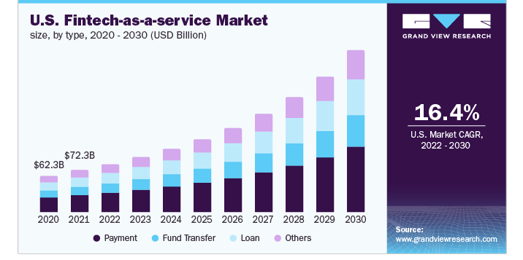
This blog will list the top 10 Fintech software development companies in the USA in 2023 that can help you bring your Fintech vision to life. So without further ado, let's dive right into the details.

Top 10 Fintech Software Development Companies in the USA in 2023

1. Appinventiv
Appinventiv is a renowned Fintech software development company with over eight years of business expertise and a team of over 1200 seasoned developers. Their profound knowledge enables them to analyze emerging digital trends and transform them into cutting-edge Fintech software solutions that cater to real business requirements.

Appinventiv empowers banks and financial institutions to embrace digitization by offering robust Fintech solutions backed by innovative technologies like Blockchain, AI, Cloud, Cybersecurity, Analytics, etc. Their Fintech software development services vary from financial software development, mobile banking software development, and wealth management software development to accounting management software development. The organization is at the forefront of driving financial organizations into the future of digital finance.

Their team of software developers can build complex architectures capable of protecting your users' data, transaction records, and network information from DDoS and other malware attacks. Making way for designing globally accessible systems that meet every local compliance, Appinventiv's Fintech solutions resonate with their technical expertise and their commitment to implementing state-of-the-art technologies.

As one of the prominent Fintech software development companies, they have solidified their position as a leading development company with a strong focus on customer-centricity. The organization has a track record of successful partnerships with esteemed brands like American Express, Vodafone, KPMG, Asian Bank, EmiratesNBD, Virgin Group, Adidas, Americana Group, and Bodyshop. Their reliability and ability to deliver innovative and cost-effective business solutions have earned them widespread recognition across the regions like the US, North Africa, Australia, Europe, the Middle East, Qatar, and India.

2. IBM

IBM's Fintech division includes a highly competent workforce dedicated to crafting, deploying, and providing support for Fintech solutions tailored to diverse industries. Leveraging their proficiency in advanced technologies, these experts empower financial institutions to increase overall operational efficiency, elevate customer experiences, and fortify data security.

IBM offers an extensive range of Fintech services designed to meet the specific requirements of banks, financial institutions, and other financial sector entities. Their Fintech solutions are backed by cutting-edge technologies, such as artificial intelligence, blockchain, data analytics, cloud computing, and cybersecurity, which offers clients a foolproof way to drive their financial operations forward.

3. Accenture

Accenture, a global IT firm founded in 1989, is a leading Fintech software services provider. They offer a range of solutions, including application development, management, maintenance, cloud services, data analytics, and cybersecurity. Their innovative solutions help businesses adapt to the rapidly evolving financial landscape and maintain a competitive edge. Their Fintech solutions prioritize risk and regulatory requirements to be taken care of, thereby safeguarding the organizations against reputational, organizational, and financial risks.

4. Capgemini

Capgemini is another renowned Fintech solutions provider in the USA in 2023 that offers robust financial solutions for businesses of all sizes. With their constantly evolving portfolio of services, their commitment to delivering digital services is backed by three core ethics: Customer First, Intelligent Industry, and Enterprise Management. Capgemini is known to leverage its deep understanding of the financial sector in assisting banks, insurance companies, and other financial organizations to stay competitive in this digital age.

5. Diceus

Diceus is a leading Fintech software development organization that was launched in 2011. They specialize in providing advanced blockchain-based solutions to financial institutions that enable cost-effective payments and transfers, secure authorization processes, and enhanced customer cybersecurity measures. By leveraging Diceus's expertise, financial institutions can offer their customers efficient and secure financial services powered by cutting-edge technologies. Their services include custom software development, web development, app development, IT staff augmentation, data warehousing, and cloud solutions.

6. Cognizant

Cognizant is an IT consulting company that offers a comprehensive range of Fintech services that cater to the evolving needs of the financial sector. With deep expertise in technology and finance, Cognizant strives to help financial institutions leverage digital solutions that can enhance their operations and customer experiences. Their fintech services include digital banking solutions, payment processing systems, mobile and online banking platforms, and risk management solutions.

7. Appventurez

With over ten years of experience delivering custom software solutions, Appventurez is a dedicated Fintech services company offering robust digital solutions to clients across various niches. They strive to deliver future-ready and client-centric mobile apps for the Fintech industry that can reinvent the digital infrastructure while facilitating exceptional growth. With the client at the center, their fintech application development process outlines the entire journey, addressing complexities effectively.

8. Symfa

Synfa is a leading custom software solutions developer based out of Florida. Launched in 2015, the organization offers various financial services that drive measurable results while supporting digital transformation. Their fintech solutions adhere to strict compliance standards, meeting privacy, security, and data management regulations. Moreover, they maintain maximum transparency by establishing open communication channels, fostering ownership, and ensuring clients are well-informed throughout development.

9. Unico Connect

Unico Connect is a top Software Development Agency known for its creative use of No Code tools. They are pioneers in this field and excel in utilizing platforms like Xano, Bubble, Flutterflow, and Webflow to craft extraordinary digital products that redefine user experiences. They strive to empower their clients with strong, flexible Fintech software solutions that promote growth, boost effectiveness, and encourage innovation.

10. Quanrio

Quanrio is an IT firm specializing in offering custom Fintech software solutions for new and established enterprises. Their skilled team delivers exceptional value with custom operating software, feature-rich apps, and more. They offer a collaborative approach and fixed-cost and time-bound exploration phases, helping clients refine their design and technological requirements efficiently.

Summing Up

Choosing the right financial software development firm is essential for the overall success of your project. Thus, it is recommended to carefully define your project requirements before you start with your research. The process is not just about finding a technically capable firm but finding a partner to realize your vision while collaborating effectively. Successful Fintech software development partnerships go beyond just development; they involve building trust and accountability with shared goals. We hope our list of top 10 software development companies in the USA in 2023 can help you choose the right digital partner for your future projects.

